Medium Voltage Switchgear Technical Summary

Switchgear Ratings and Specifications
This document provides a general technical overview for typical medium-voltage switchgear assemblies used in indoor and outdoor installations, designed in alignment with ANSI and IEEE standards. All data and visual materials are for general engineering reference only and may be adapted for client-specific publications or technical reviews.

1. Switchgear Typical Specifications
Specification | NEMA 1 (Indoor) | NEMA 3R (Outdoor)
Application | Indoor Medium Voltage Distribution | Outdoor Medium Voltage Distribution
Enclosure Type | NEMA 1 (Indoor, Non-Gasketed) | NEMA 3R (Outdoor, Weatherproof)
Rated Voltage | Up to 38 kV | Up to 38 kV
Rated Current (Main Bus) | Up to 4000 A | Up to 3000 A
Short Circuit Rating (kAIC) | Up to 63 kA | Up to 40 kA
Basic Insulation Level (BIL) | 95 kV | 150 KV (optional 170KV)
Power Frequency Withstand | 36 kV | 60 kV
Operating Frequency | 60 Hz | 60 Hz
Ambient Temperature Range | -20°C to +40°C | -30°C to +40°C
Altitude Rating | Up to 1000 meters without derating | Up to 1000 meters without derating
Compliance Standards | ANSI C37.20.2, IEEE C37.04, C37.013A | ANSI C37.20.2, IEEE C37.04, C37.013a

2. BIL Ratings by Voltage Level
Rated Voltage (kV) | BIL (kV)
2.8 kV | 60 kV
5 kV | 60 kV
15 kV | 95 kV
27 kV | 125 kV
38 kV | 150 kV (170KV optional)

3. Equipment Derating Curves
*Altitude Derating Curve — Load Current Capacity*  - Equipment current and insulation capability may reduce at elevations above 1000 meters due to lower air density.  - Derating factors:  - 0 meters: 1.00  - 500 meters: 0.98  - 1000 meters: 0.96  - 1500 meters: 0.94  - 2000 meters: 0.92  - 2500 meters: 0.90  - 3000 meters: 0.88  - 3500 meters: 0.86  - 4000 meters: 0.84  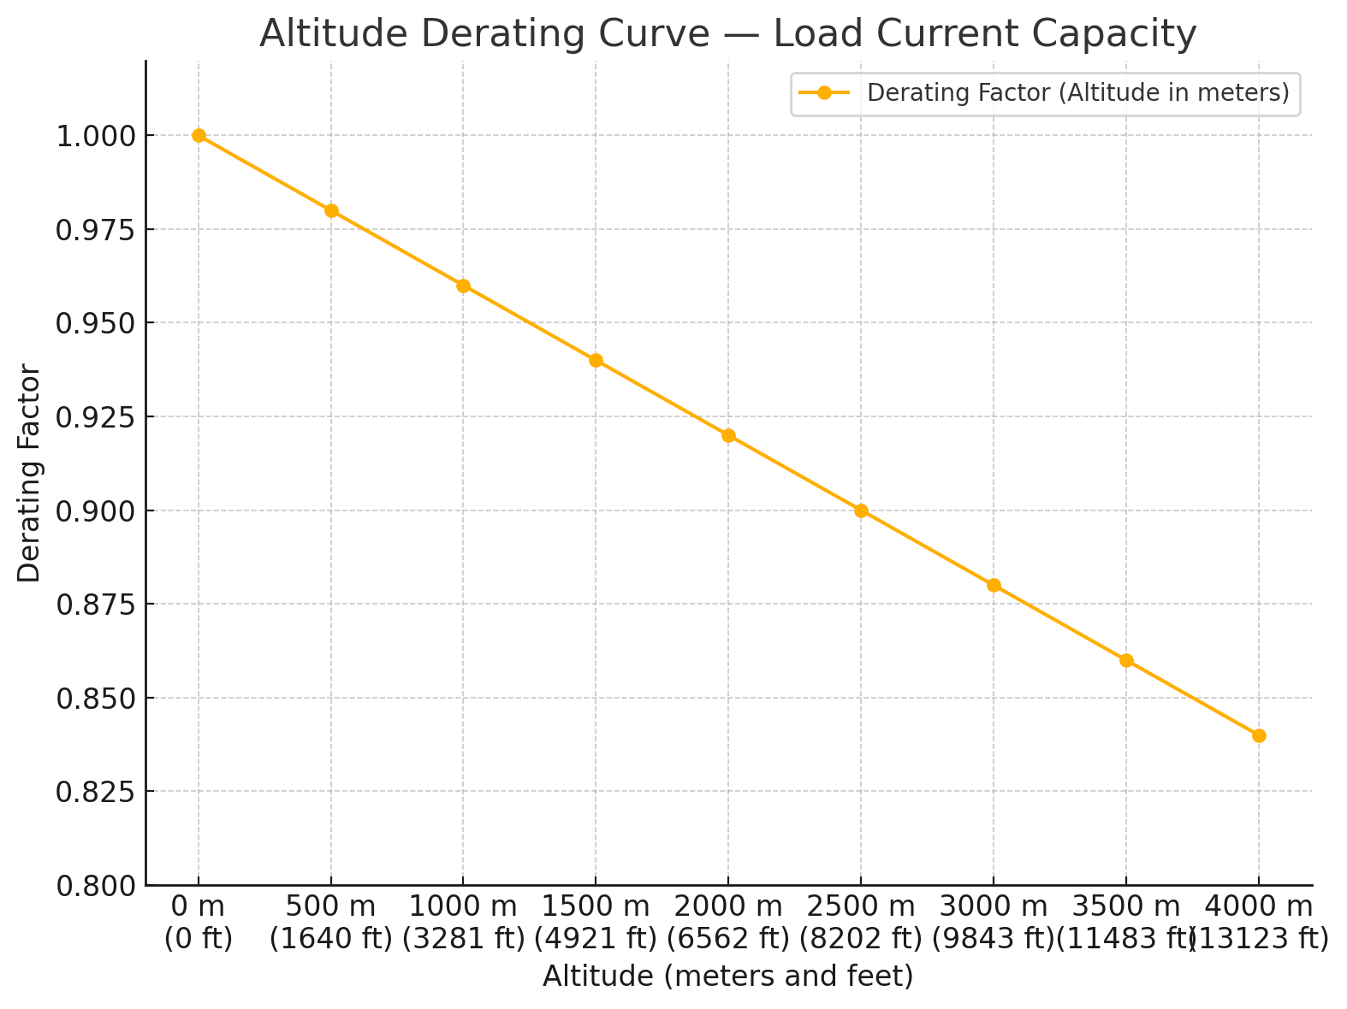 | *Temperature Derating Curve — Load Current Capacity (in degrees Fahrenheit)*  - Higher ambient temperatures reduce the current-carrying capacity of conductors and busbars.  - Derating factors:  - -4°F: 1.02  - 14°F: 1.01  - 32°F: 1.00  - 50°F: 0.99  - 68°F: 0.97  - 86°F: 0.95  - 104°F: 0.92  - 122°F: 0.88  - 140°F: 0.85  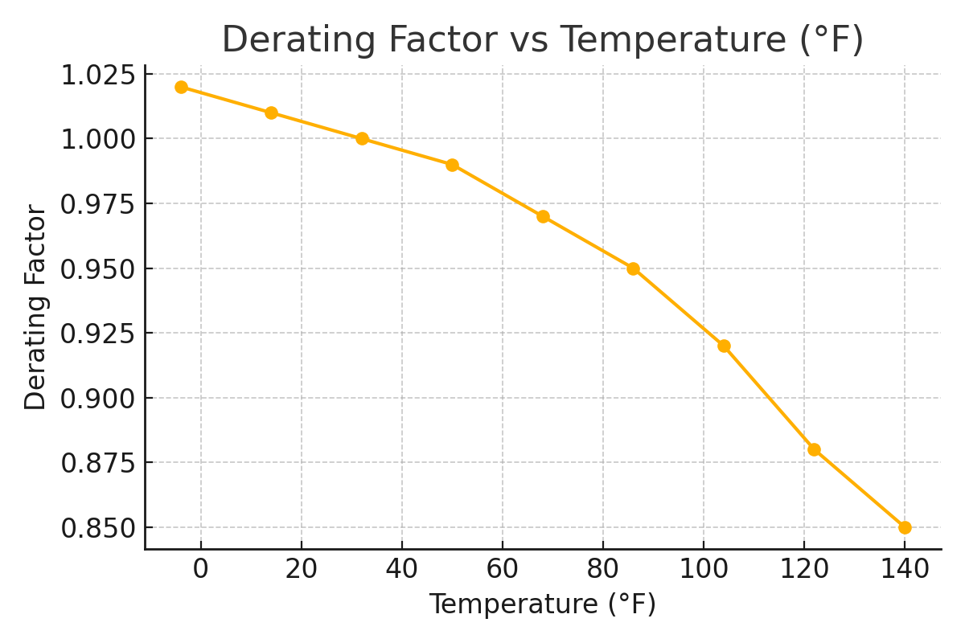

*BIL Derating Curve by Altitude — Impulse Withstand Capability*  - Impulse withstand ratings (BIL) may decrease at high altitudes due to reduced air insulation strength.  - Example derating factors:  - 0 meters: 1.00  - 1000 meters: 0.98  - 2000 meters: 0.94  - 3000 meters: 0.90  - 4000 meters: 0.86  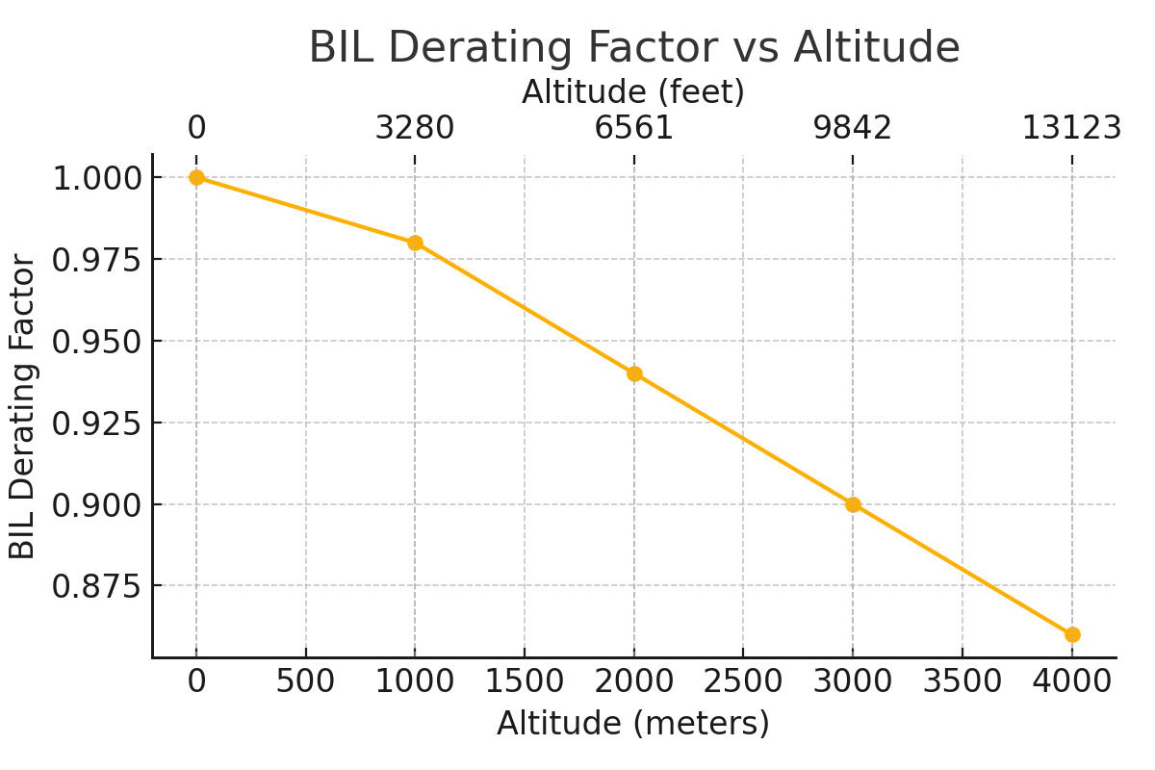 | *BIL Derating Curve by Temperature — Impulse Withstand Capability (°F)*  - Elevated temperatures can degrade dielectric properties, reducing BIL effectiveness.  - Example derating factors:  - -4°F: 1.02  - 32°F: 1.00  - 68°F: 0.97  - 104°F: 0.93  - 140°F: 0.87  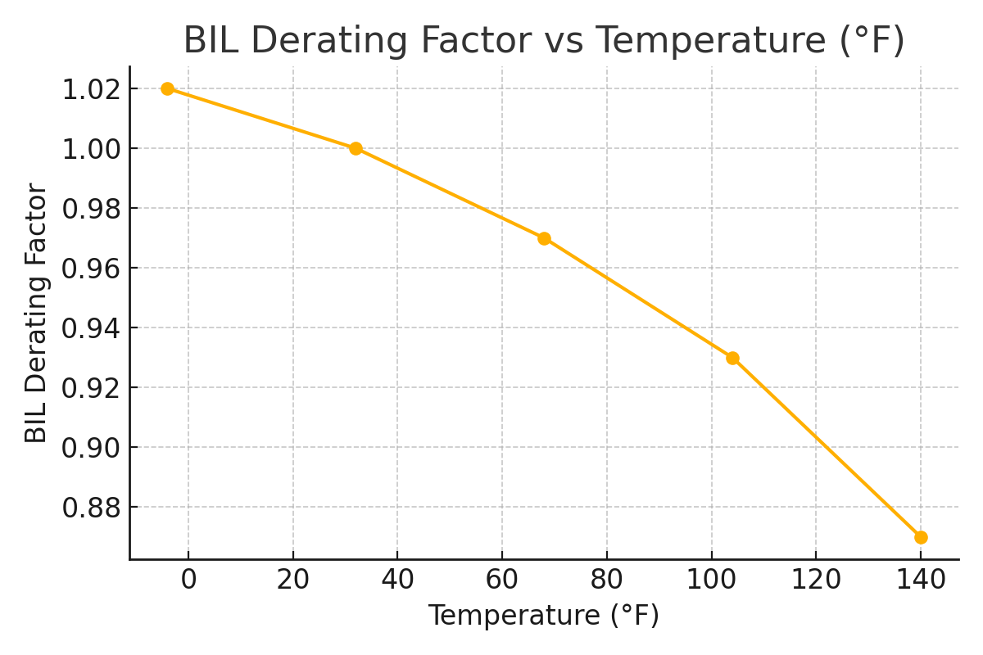

Sources and Legal Notice
- This document has been prepared in reference to ANSI C37.20.2, IEEE C37.04, and general medium-voltage design principles.
- All curves have been independently generated for informational use and do not reference or reproduce proprietary materials.
- No part of this document reproduces, copies, or mimics branded or certified material from third-party manufacturers.
- Publication of this material is legally permitted as it uses public domain engineering knowledge and internal data modeling.
- Compliance references to standards (ANSI/IEEE/UL) are descriptive and not declarations of certification.
**Disclaimer:** This document is intended for general engineering reference only. Product-specific performance should be verified using official manufacturer certifications and test data. The information is believed to be accurate but is not legally binding and does not substitute for formal design validation.
**Prepared for: Switchgear Resources, inc.**
**Date: May 16, 2025**

